**GOVERNMENT COLLEGE OF ENGINEERING SRIRANGAM**

**DEPARTMENT OF ELECTRONICS AND COMMUNICATION ENGINEERING**

**ARTIFICIAL INTELLIGENCE BASED RESUME ANALYZER**

**DOMAIN : ARTIFICIAL INTELLIGENCE**

**Presented by**

1. S.HARIHARAN 830121106013
2. Y.M.KOHILA 830121106020
3. J.SABITHA SRI 830121106034
4. K.SENTHIL 830121106039

**Under the Guidance of**

Dr.R.RANJITH

ASSISTANT PROFESSOR

DEPARTMENT OF ELECTRONICS AND COMMUNICATION

ENGINEERING

GOVERNMENT COLLEGE OF ENGINEERING SRIRANGAM

## PROJECT REPORT

## **21st March (2nd review)**

* Performed system requirement analysis (both hardware and software).

**HARDWARE REQUIREMENTS**

1. A Laptop / Desktop Connected with Internet.
2. Minimum of 4GB ram or more.
3. Single Network Connection.
4. So that other devices within network can connect through network URL.

**SOFTWARE REQUIREMENTS**

1. MySQL
2. Python
3. Browser (chrome recommended)
4. Text Editor (Visual Studio Code recommended)

* Selected tools and frameworks: Python, NLP libraries (spaCy), scikit-learn, Flask, etc.
* Identified key modules: Resume Parser, Keyword Extractor, Job Matcher, Feedback System.
* Designed architecture diagram of the complete system.
* Created flowcharts and module-wise layout for implementation.
* Developed UI wireframes for web interface (HTML, CSS, JS with Flask backend).
* Started coding the Resume Parsing module using PDFMiner and docx2txt.



## **21st April (4th review)**

* Completed Resume Parser module with proper extraction of text from PDF and DOCX files.
* Implemented NLP preprocessing pipeline: tokenization, stopword removal, lemmatization.
* Started building the Keyword Extraction module using spaCy and TF-IDF.
* 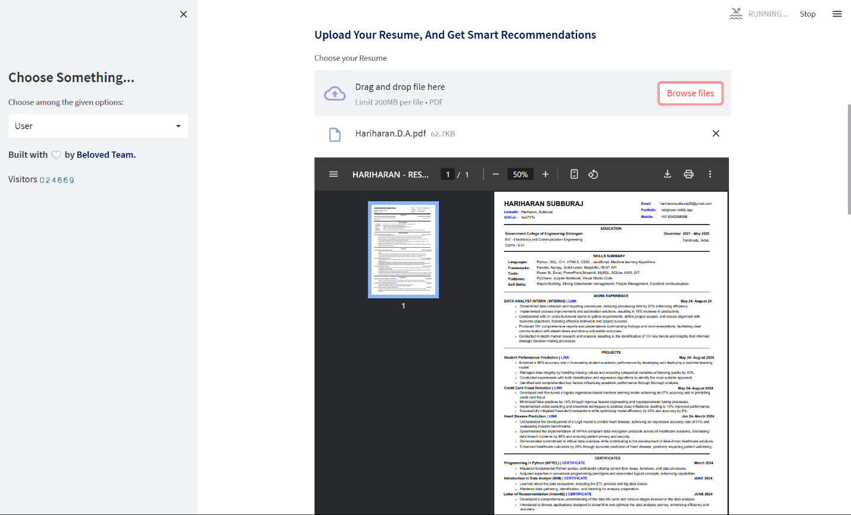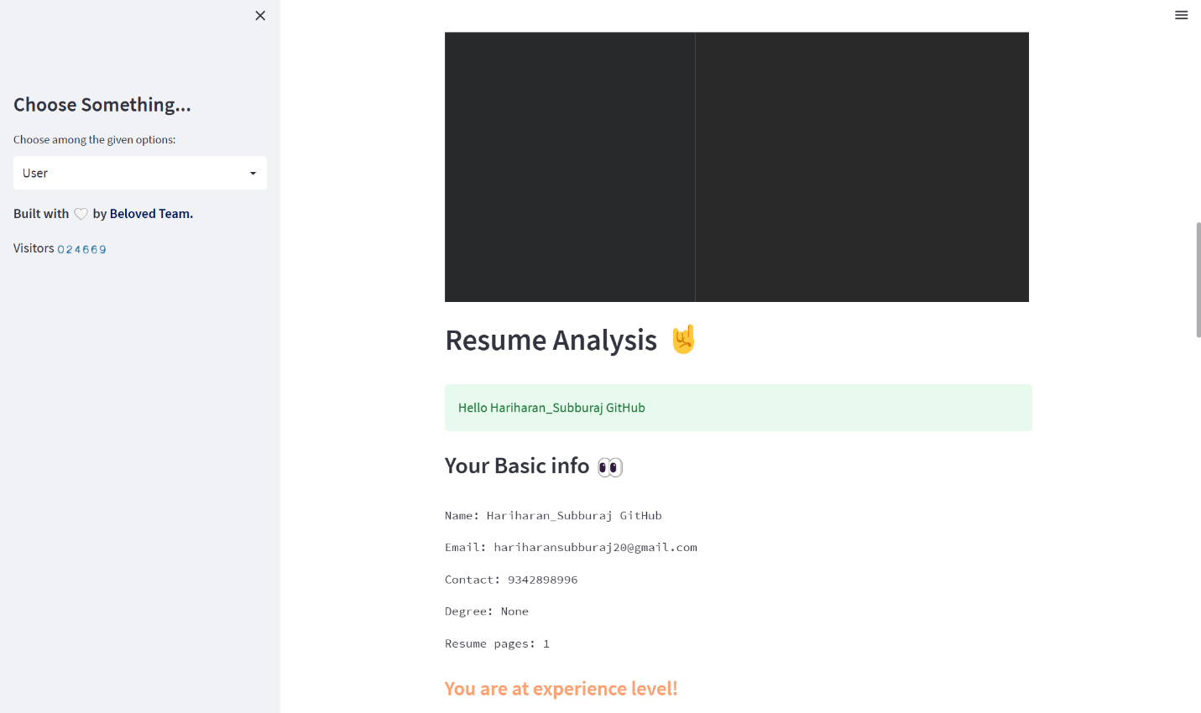
* Completed Resume Parser module with proper extraction of text from PDF and DOCX files.

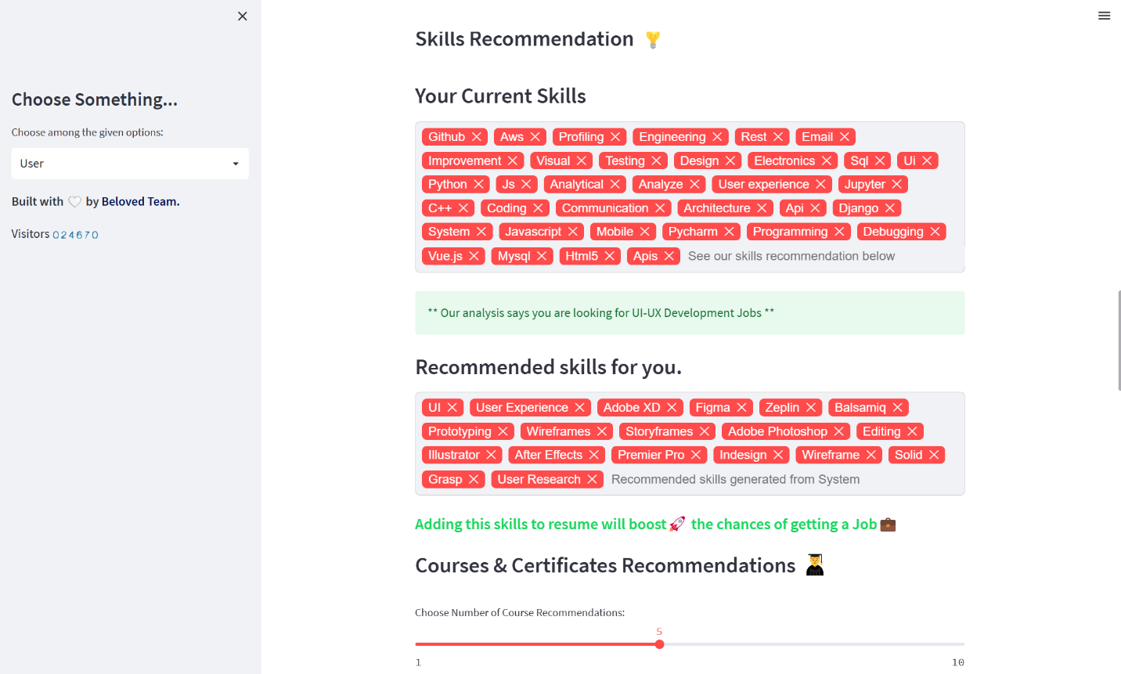

* Integrated Job Description comparison module using cosine similarity.
* Developed ranking logic for matching resumes with job postings.
* Conducted unit testing for each module.
* Mid-review session with guide, received feedback for UI improvements and feature refinement.

